PRACTICAL 9
BLACK-BOX & WHITE-BOX TESTING

Part A — Black-Box Testing
Method: Execute tests through the website interface. Do not inspect the website's internal source code. Record the actual result and status after running each test.

Test Case ID: BB01
Scenario: Verify product search with valid keyword
Steps:
1. Open the nopCommerce demo website: https://demo.nopcommerce.com/.
2. Enter a valid product keyword, such as Laptop, in the search box.
3. Click the Search button.
4. Verify that matching products are displayed.
Expected Result: Matching products should be displayed.
Screenshot: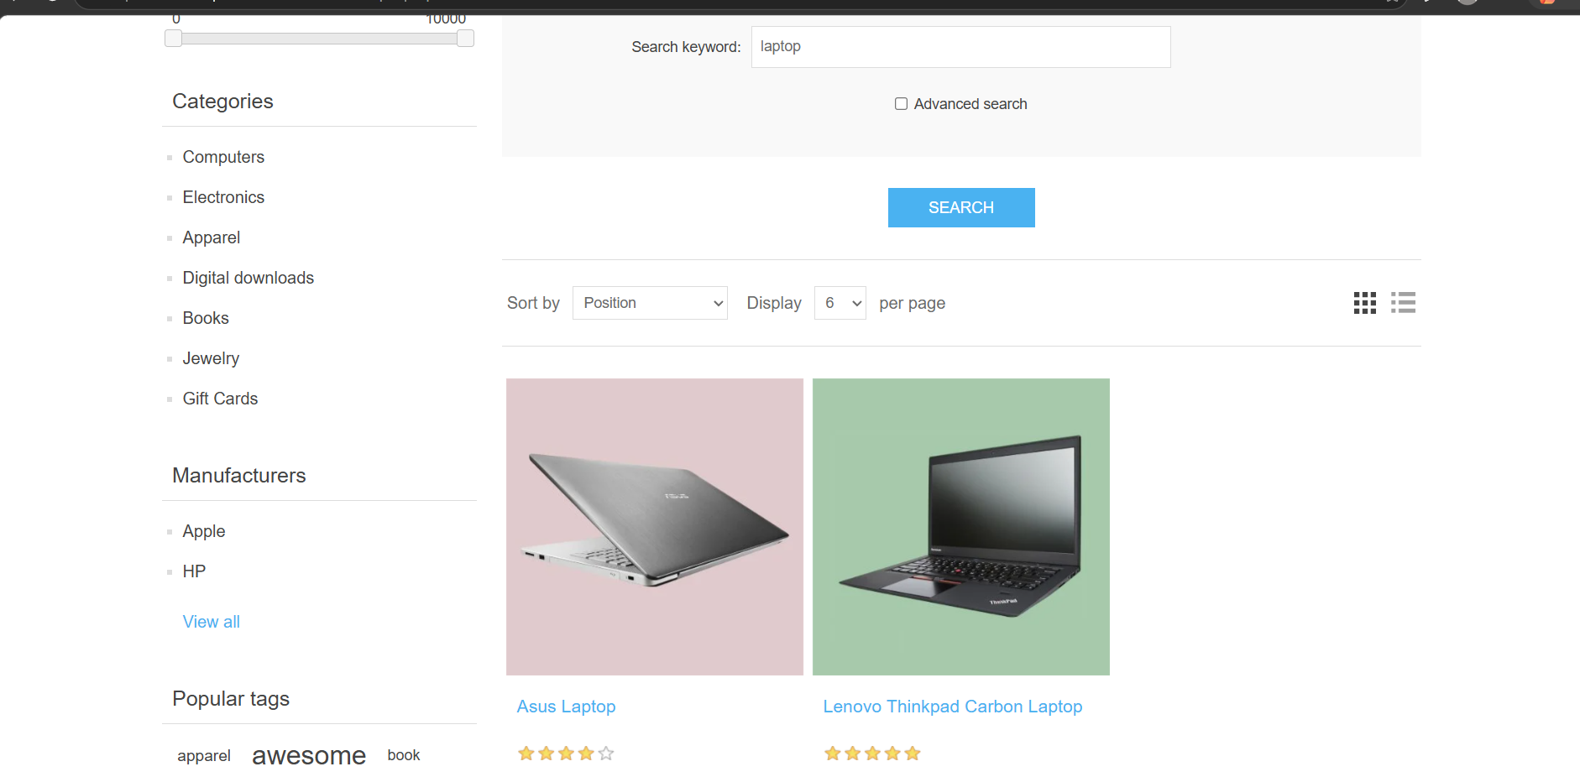

Test Case ID: BB02
Scenario: Verify product search with invalid keyword
Steps:
1. Open the nopCommerce demo website.
2. Enter an invalid product keyword, such as XYZ12345, in the search box.
3. Click the Search button.
4. Verify that no matching products are displayed or a no-results message appears.
Expected Result: No matching products should be displayed, or a no-results message should appear.
Screenshot: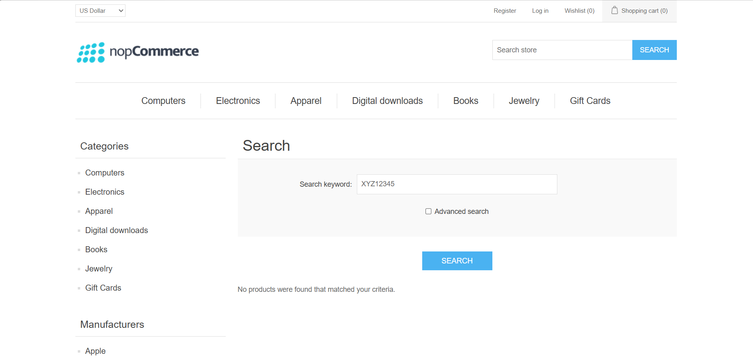
Paste screenshot here.

Test Case ID: BB03
Scenario: Verify that a product can be added to the shopping cart
Steps:
1. Open the nopCommerce demo website.
2. Search for or select an available product.
3. Open the product details page if required.
4. Click Add to cart.
5. Open the shopping cart and verify that the selected product is listed.
Expected Result: The selected product should appear in the shopping cart.
Screenshot: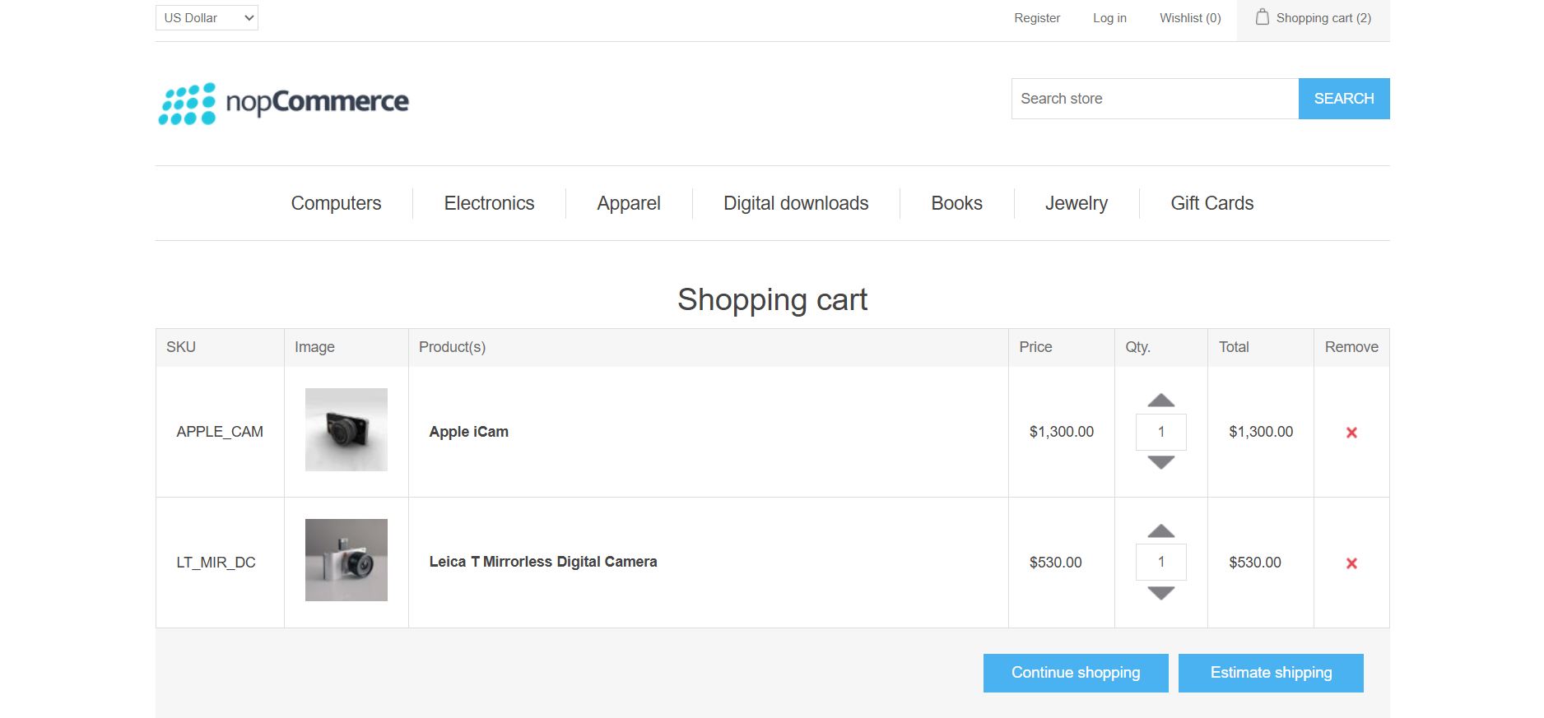

Test Case ID: BB04
Scenario: Verify cart total updates after changing product quantity
Steps:
1. Open the nopCommerce demo website.
2. Select a product and click Add to cart.
3. Open the Shopping Cart page.
4. Change the product quantity to a different valid value.
5. Click Update shopping cart if that button is shown.
6. Verify that the quantity and cart total are updated correctly.
Expected Result: The displayed quantity and cart total should update correctly.
Screenshot:
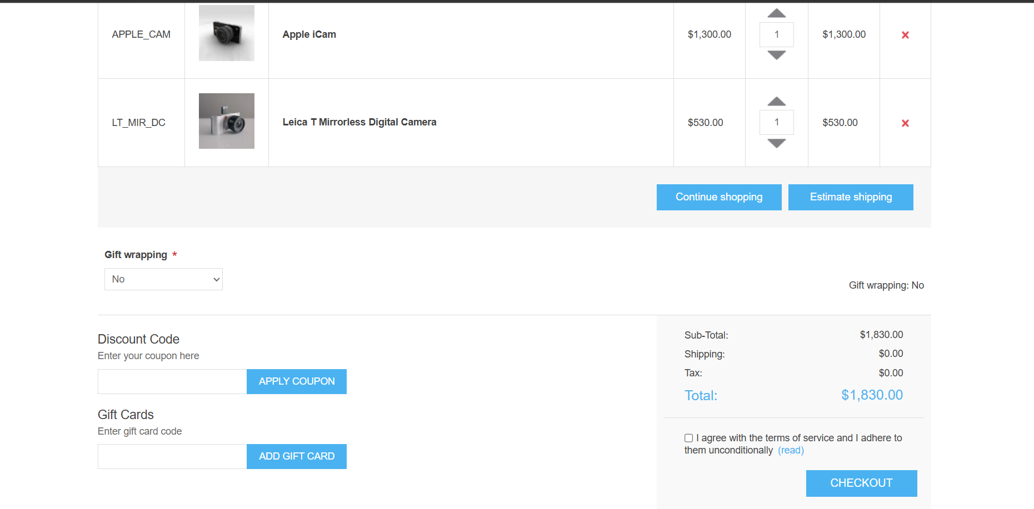
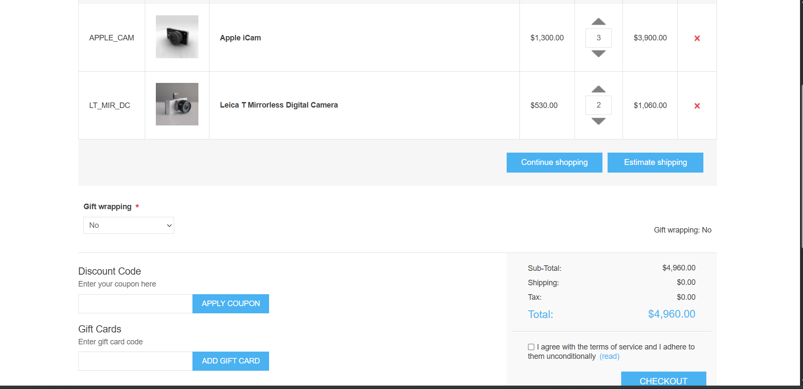
Part B — White-Box Testing
Method: Examine the statements and calculation logic of the sample C++ program. This is an illustrative program, not the actual source code of nopCommerce.

Sample C++ Source Code
def calculate_cart_total(price, quantity):
if quantity > 0:
total = price * quantity
print("Cart Total:", total)
else:
print("Invalid quantity")

# Test Case 1: Valid quantity
calculate_cart_total(100, 2)

# Test Case 2: Invalid quantity
calculate_cart_total(100, 0)

Expected Output
Cart Total: 200

White-Box Test Cases
Test Case ID | Test Scenario / Logic | Input | Expected Result
WB01 | Normal calculation | Price = 100, Quantity = 2 | Total = 200
WB02 | Quantity equals 1 | Price = 100, Quantity = 1 | Total = 100
WB03 | Quantity equals 0 | Price = 100, Quantity = 0 | Total = 0
WB04 | Different price | Price = 250, Quantity = 2 | Total = 500
WB05 | Check multiplication logic | Price = 50, Quantity = 4 | Total = 200
WB06 | Negative quantity handling | Price = 100, Quantity = -1 | Should be rejected only if validation is implemented; original sample does not validate it

Note: These white-box cases apply to the illustrative C++ program in this practical, not to the internal source code of nopCommerce.

Test Case ID: WB01
Scenario: Verify normal cart-total multiplication logic
Steps:
1. Open visual studio code.
2. Enter or open the sample cart-total program.
3. Set price = 100 and quantity = 2.
4. Compile and run the program.
5. Verify that the output is Cart Total: 200.
Expected Result: Cart Total: 200
Screenshot: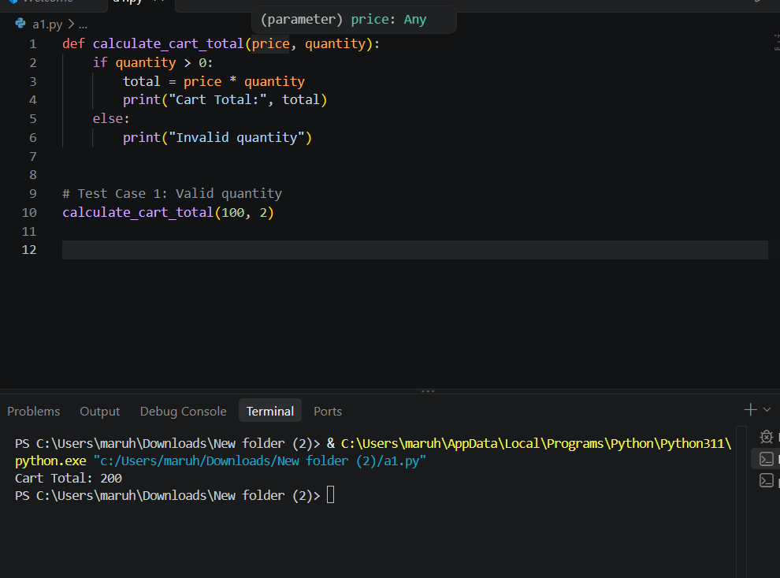

Test Case ID: WB02
Scenario: Verify calculation when quantity equals 0
Steps:
1. Open the sample C++ program in the compiler or IDE.
2. Set price = 100 and quantity = 0.
3. Compile and run the program.
4. Verify that the calculated total is 0.
Expected Result: Cart Total: 0
Screenshot: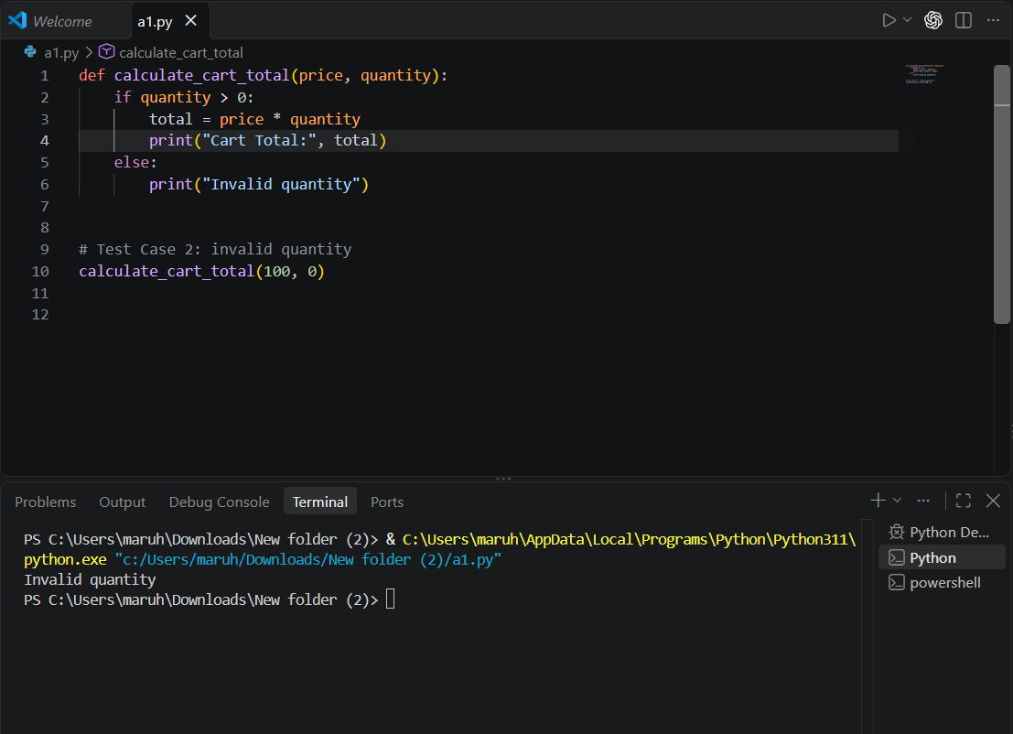

Test Case ID: WB03
Scenario: Verify calculation with a different product price
Steps:

1. Open visual studio code.
2. Set price = 250 and quantity = 2.
3. Compile and run the program.
4. Verify that the calculated total is 500.
Expected Result: Cart Total: 500
Screenshot: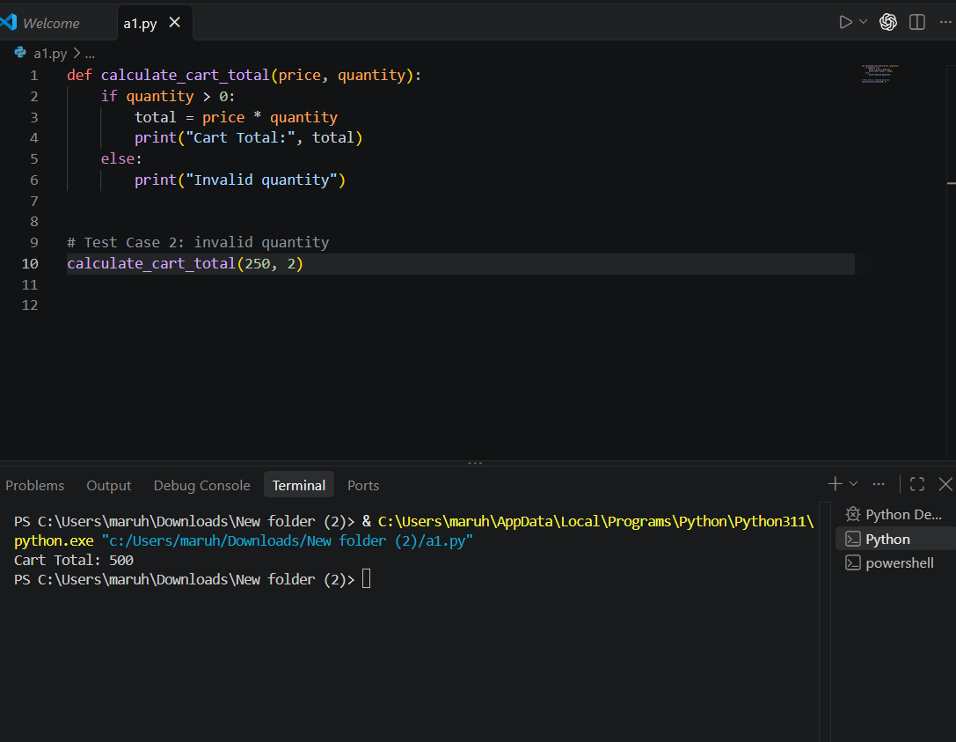
.

Test Case ID: WB04
Scenario: Inspect behavior for a negative quantity
Steps:
1. Open visual studio code.
2. Set price = 100 and quantity = -1.
3. Compile and run the program.
4. Observe the result and inspect whether the code contains a validation condition for negative quantity.
5. Record that the original sample has no validation and therefore does not reject a negative quantity.
Expected Result:invalid.
Screenshot: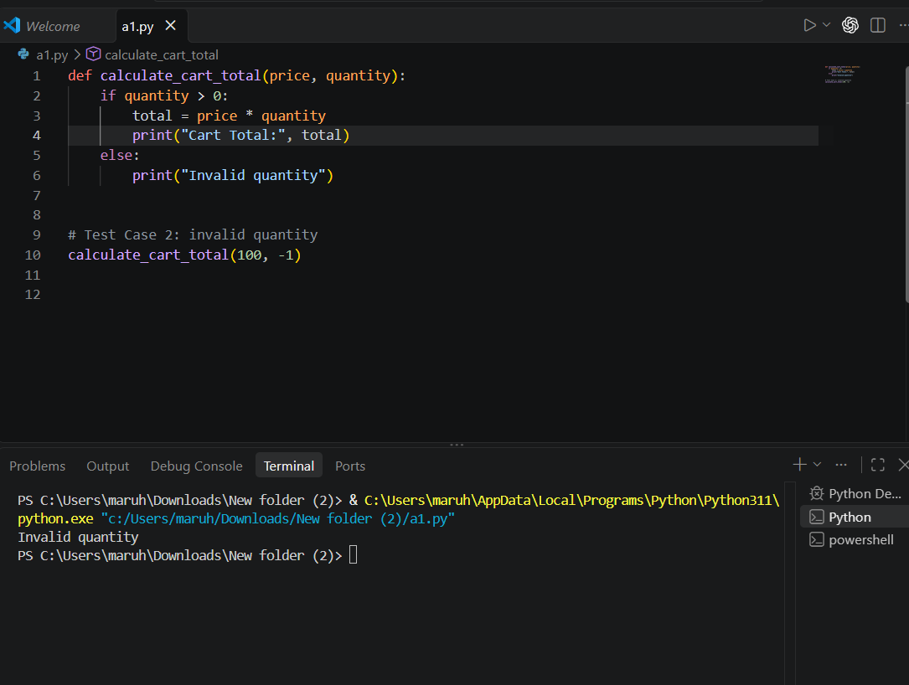

Conclusion
This demonstrates the difference between testing software functionality from the outside (black-box testing) and examining internal program logic (white-box testing). Integration testing and system testing were also considered for the e-commerce workflow.

Result / Output
Black-box test cases were prepared for the nopCommerce demo website, and white-box test cases were prepared for a sample C++ cart-total program. Actual results and screenshots should be added after performing the tests.

